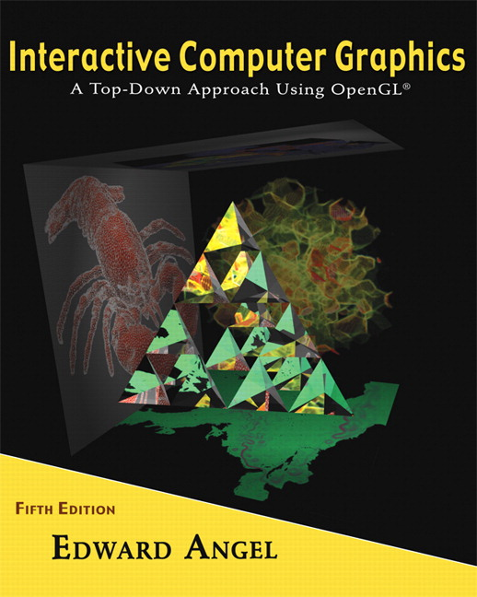

Name: ______________________ Terminal # ____

Programming Assignment 2
(100 points)

The Programming Assignment is to be turned in the first ten minutes of the due date class as:

Hardcopy (with your terminal #!)
Source Code and screenshots that shows that your Visual Studio 2010 “Programming Assignment 2” PROJECT compiles and runs!

Electronic: Submit the Visual Studio2010 “Programming Assignment 2” zipped PROJECT to BB so you can run it in 200 PGH!

“Humanoid - Summer 2011” Modeling Instructions
(The file “Humanoid Summer 2011.pdf” contains the specifications for the humanoid that you will modeling.)

1. The glutCreateWindow OpenGL call will take as parameter “YourLastName Humanoid Version 2”.
2. Start with the Humanoid.c that you have created in Programming Assignment 1 and call the file MyHumanoid.c. Please make sure that the colors schema is observed.

3. Create a menu or keyboard (f, b, r, l, t, u, i) that allows that you to view the Humanoid from:

- front;
- back;
- right side;
- left side;
- top;
- under;
- isometric.

Get a screenshot of the “YourLastName Humanoid Version 2” window for each view.

